The Early Work of the Church
Dear Wednesday Night Class,
There is no possible way that we can cover all of the material we’ve missed in the last couple of weeks. This handout is an attempt to hit some of the high points that I noticed during our readings and stimulate your thought and interaction with this material.
If you are behind, please make plans to finish up. So many of you have come so far this year, and I hope that we can all make our goal of reading through the entire Bible this year together.
Some additional material is available on the website: http://www.happyhiatt.com . Let me know if you have any other questions!
Matthew
Week 47: The Passion Week and the Death of Jesus
- Did you notice the time progression in the gospels? The time-context of the chapters always impresses me each time I read them. Mark is 16 chapters. The first 10 chapters cover 2 ½ years or so. The last 6 chapters essentially cover a couple of weeks.
- Context! Did you notice how many well-known parables were taught in the context of Christ’s last week on earth? The parable of the “murderous tenants”, the talents, the wise and foolish virgins, and others were taught within 96 hours of his death.
- The crowd sure changes their minds quickly, don’t they? After the parable of the murderous tenants, the crowd shouted “May it never be!” At the Last Supper, the disciples kept asking “Is it I?” and by the crucifixion, they shouted “Crucify Him!” and “I do not know the man.”
- The Olivet Discourse is the fancy name for that section of teaching about the destruction of the temple / Jerusalem / and the “end of the age.” Read it very carefully.
- The fig tree cursing: this story sounds problematic for a lot of folks. Most Mediterranean fig trees bore buds (or pre-figs) before they sprouted leaves. A fig tree that didn’t have fig-buds but did have leaves was not going to bear fruit at all.
- Timeline of the last week. F. LaGard has some interesting ideas about this – and I’m not sure if he’s right or wrong.
  - Traditional view: Jesus died on Good Friday (because it’s the day before the Sabbath). The problem is scripture prophesied that he’d be buried 3 days and 3 nights. This could just be an idiom for saying three days, so it may not be a problem.
  - LaGard’s view: as part of the feasts, the day of preparation for the Passover was a special Sabbath-like day: no work, special sacrifices, etc. If it fell on a Friday, you essentially had two Sabbaths in a row. It could be that Jesus died on Thursday, thus Friday and Saturday were both “Sabbaths” solving the 3-day 3-night dilemma.
- Neat things to study at the crucifixion:
  - The different trials or hearings (Annas, Caiphas, Sanhedrin, Pilate, Herod, Pilate)
  - The “seven sayings” on the cross.
  - The crucifixion phenomena: earthquake, dead raised, darkness (impossibility of an eclipse due to LUNAR calendar—and this is attested to by ancient writers), etc.
  - The confession of the Centurion: “Surely this was…”
Week 48
Perhaps the only thing more significant than the death of Jesus for our sins is the fact that he overcame it – his resurrection!
- Did you notice that Jesus kept on “appearing”? It sort of sounds like he wasn’t just camped out on earth.
- What about his command to Mary: “Don’t cling to me!”?
- What can we learn from good ol’ Doubting Thomas?
- The “Lovest Thou Me” passage with Peter. What about John’s death?
- What were some of the last teachings of Jesus pre-resurrection?
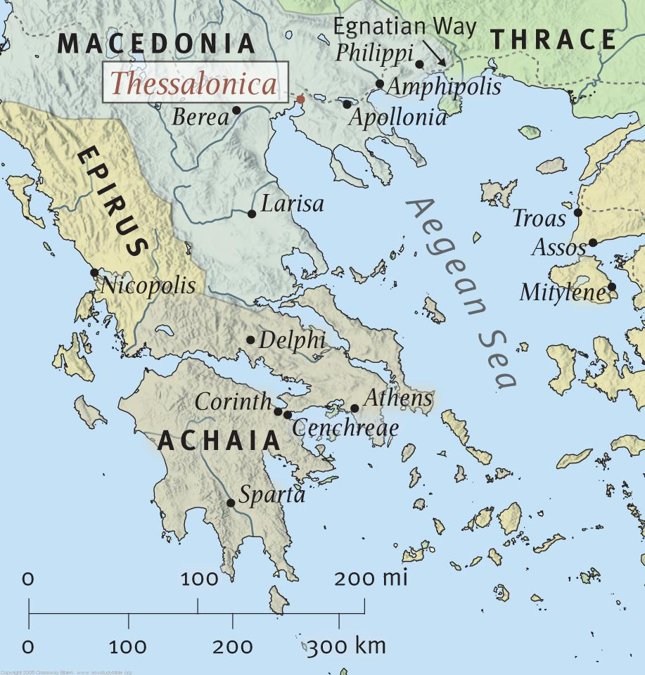
Acts is special because of what it records: the actions of the apostles and the early church. We take many cues from the book of Acts as to how the early church acted…and that helps us understand the principles that should guide us as a church today.
Big moments in Acts:
- The Pentecost Sermon (Acts 2)
- Stephen’s Martyrdom (Acts 8)
- Ananias and Sapphira (Acts 5)
- Conversion of Saul Paul (Acts 9, 22, etc)
- The Kingdom Opened to Gentiles
- The Judaizers and their Conflicts (Acts 15)
Week 49: The Young Church
The book of Galatians is hard to date – but it describes many of the same issues Paul dealt with in Acts 15, thus its placement on page 1513.
- What relationship does law have to those who are in Christ?
- What benefit and what liability did the law put before new Christians – both Jews and Gentiles?
Missionary journeys continue in the book of Acts. I’m very bad at following them…but along the way, we meet several churches. Thessalonica is a happier encounter than Galatians: Paul notes their work of faith, their labor of love, and their endurance from hope—and continues to encourage them. The two Thessalonian letters deal more with eschatology (last things, second coming, parousia) than any other letters. Some have suggested that 1 Thessalonians emphasizes heavily that Jesus is coming—soon…while 2 Thessalonians reminds people that they don’t know exactly when soon is, and so, they better keep on working. Regardless: the books are encouraging and motivate people to continue steadfastly in Christ.
After a brief return to the scene of persecution in Acts, our reading goes to the lovely, happy, and thoroughly sound Corinthian church. (Those were lies!)
Some thoughts from the Corinthian Correspondence:
- The sources and solutions to church division.
- How should the church deal with immorality. Love the sin and hate the sinner?
- Contentment: marriage, spiritual gifts…ahh: LOVE. (1 Corinthians 13)

